

**Boost AI Search & Discovery**

[Document subtitle]



September 18, 2023

**Boost AI Search & Discovery**

The Shopify app Boost AI Search & Discovery offers a number of features to support company by enabling personalize product filter options and advanced site search functionalities.

**Install Boost AI Search & Discovery in your Shopify store: -**1. Log in to the Shopify App Store.

2. Settings -> Apps and sales channels -> Shopify App Store -> search and install boost ai search and discovery.

3. app automatically duplicates your live theme and renames the duplicate theme as **[Boost] Live theme with filter & search 1**. You can test the app’s features on the duplicate theme without affecting your live theme.

4. Click **Take me to Homepage** to start.

**Boost AI Search & Discovery dashboard: -**There is a menu bar with most features of app are located;  
  
# Home  
# Sync  
# Analytics  
# Filter  
# Search  
# Merchandising  
# Recommendation  
# Theme  
# Tool  
  
**Sync**Sync recent update is the process used for updating changes in your product data and some other app settings in general. We trigger this sync automatically and frequently every couple of minutes, so rest assured your product data is updated all the time.

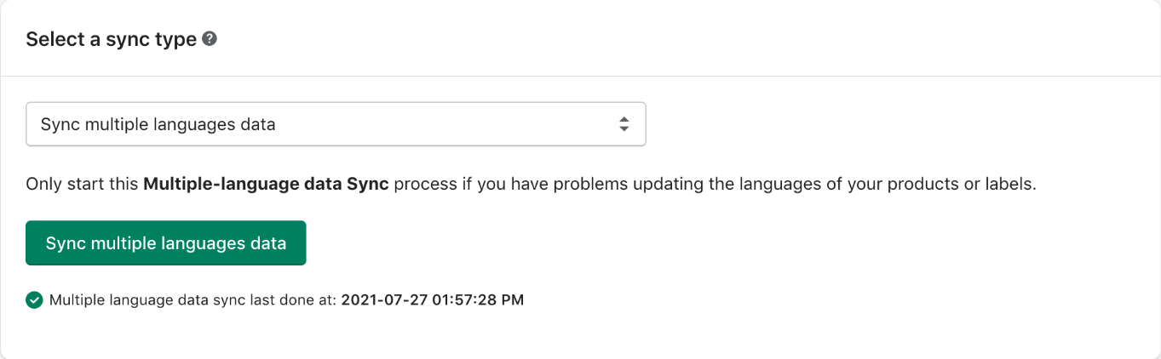

1. **Create your Boost All collection in your Shopify admin**

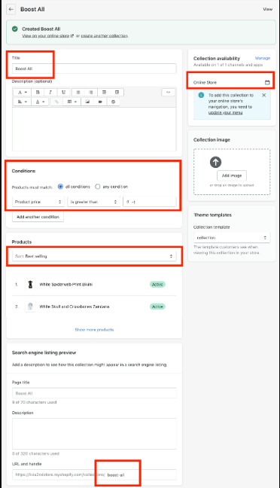  
  
**2.** Sync best selling order with Boost AI Search & Discovery app  
  
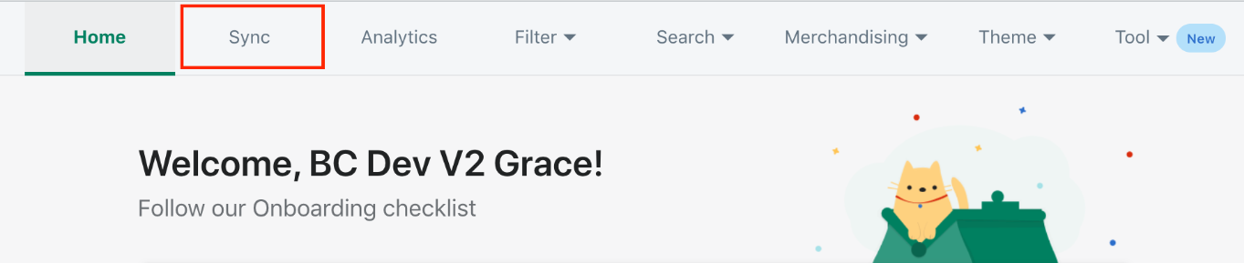

* From the sync type drop-down, select the **Sync best selling sorting order**option. And Select the Sync best selling sorting order button.

## Sync schedule

Here are the steps to create a sync schedule.  
1. Go to **Sync** > Switch to the **Sync Schedule** tab  
2. Select a sync type.  
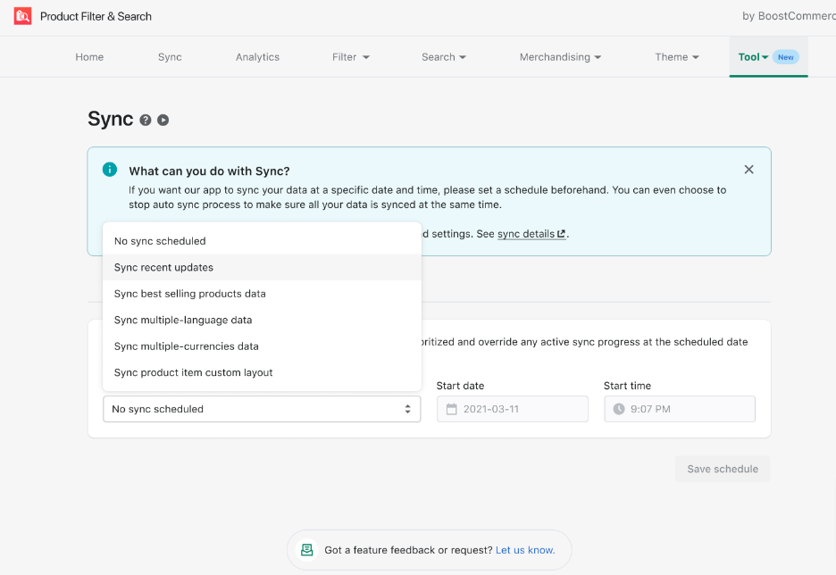  
  
3. Select the **start date** and **start time.**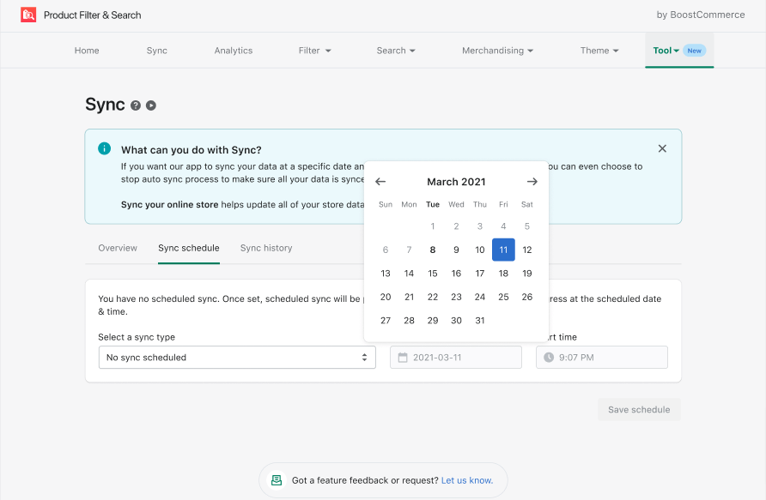4. Click the **Save Schedule**button

## **Sync history**

Sync history displays all records of Manual sync, Auto-sync, and Scheduled sync in the last 30 days. A Sync event thumbnail includes:  
  
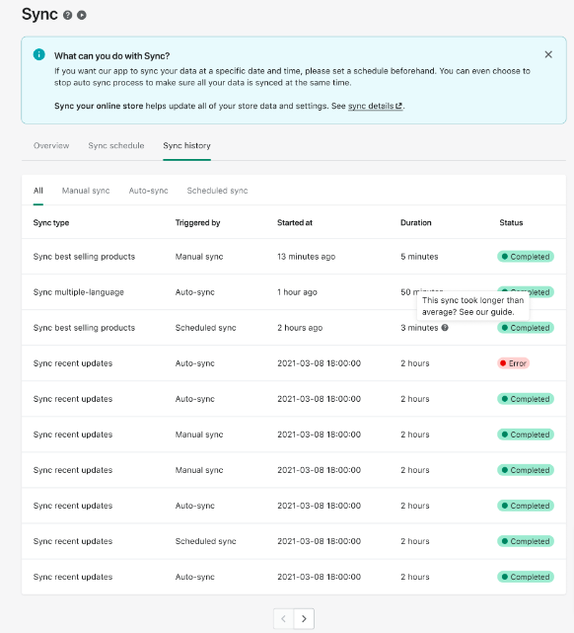

**Analytics**

Boost AI Search & Discovery provides a dashboard with detailed insights and analytics on customer behavior and your products.  
The Analytics section contains the analytics of our main features that help you learn more about your sale and customer in great detail.

Analytics feature provides you with 4 main analytics:   
**App Impact**, **Collection Analytics**, **Search Analytics** and **Recommendation Analytics**.  
  
**To export your Analytics data:  
1.** From the app’s admin, go to **Analytics**.  
2. Go to the **Collections Analytics** tab or **Search Analytics** tab based on which one you want to download the data from.  
3. Click the **Export** button on the top right of the Analytics dashboard.

4.Select **the desired collection**, **date range**, and **format** of the file you are going to receive.

5.Click **Save**.

**Filters**Boost AI Search & Discovery allows you to create different filter trees with different filter options for each collection page and search result page based on your desire.  
  
Filters feature provides you with 6 main filters:  
Manage Filter Trees, **Filter layout, Filter settings**, Merge values, Custom range sliders and **Swatch settings.**

To enable and disable a filter tree:

1. From the app’s admin, go to Filter  > Manage filter trees.
2. Toggle the Status button of the filter tree that you want to enable to disable.

To create a custom filter tree:

1. From the app’s admin, go to Filter  > Manage filter trees.
2. In the Custom filter trees section, click Add new filter tree.
3. Fill in the name of this filter tree and select one or multiple collections that you want this filter tree to apply to.
4. Click Add filter option to fully set up this filter tree with necessary product attributes.
5. Click Save on the Edit filter option page after you complete setting up a filter option.
6. Click Save on the Filter options page.

To clone a filter tree:

1. From the app’s admin, go to Filter  > Manage filter trees.
2. Click the duplicate icon of the filter tree that you want to clone and select the number of clones you want to create.

Note: Duplicates of the Default filter tree and Search filter tree will be assigned in the Custom filter tree section.

To delete a filter tree

1. From the app’s admin, go to Filter  > Manage filter trees.
2. Click the trash icon of the filter tree that you want to remove. Keep in mind that deleted filter trees cannot be recovered.
3. Click Delete.

**To hide a filter tree from a specific collection**

App allows you to hide any type of filter tree from a specific collection in your Shopify store:

1. From your Shopify admin, go to **Products** > **Collections**.
2. Click on the collection that you want to temporarily remove the filter tree created by our app.
3. In the Online store section, choose**boost-pfs-original theme** in the drop-down of **Theme template**.
4. Click**Save**.
5. Check if the collection does not have a filter tree created by our app on your storefront.

In total, the app allows you to set up unlimited filter options based on the following criteria: **collection, vendor, color, size, product type, price, variant’s price, percent sale, inventory location, review rating, stock status, weight, tag, and multi-level tag.  
  
To customize your current filter layout:**

1. From the app’s admin, go to **Filter**  > **Filter layout.**
2. Select your current filter layout: **Vertical layout** or **Horizontal layout**. Utilize our previews and select your preferred setting.

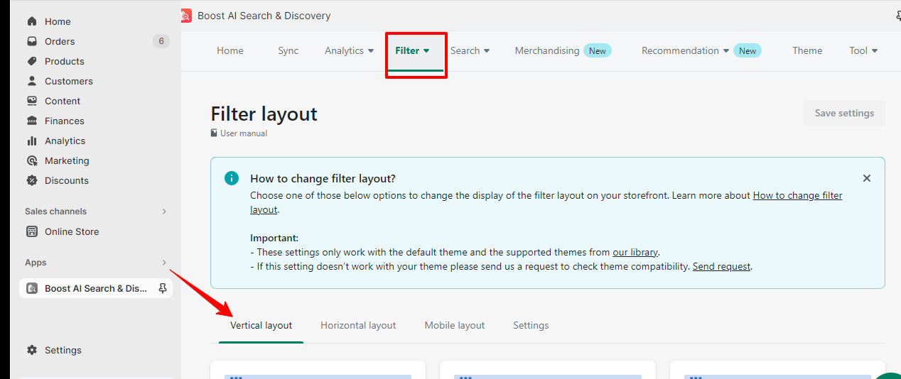

1. **[Optional]** Visit the **Mobile layout** tab to select your preferred layout on mobile.
2. **[Optional]** Visit the **Settings** section to allow your filter layout to stick when your customers scroll up and down through the product list. Toggle the **Sticky filter on Desktop** and **Sticky filter on Mobile**buttons to implement a sticky filter layout on desktop and mobile versions.
3. Click **Save settings.**
4. Check how the new filter layout appears on your storefront.

**Merge values**

1. From the app’s admin, go to **Filter**> **Merge values.**

2. Click **Add new merged value.**

3. Select **Type/Vendor/Title/Height/Size/Color/Tag** in the drop-down of **Type.**

4. In the **Merged value** section, click **Add new merged value.**

5. Under the **Merged value** heading, enter the phrase into which you are about to merge some values. In the example above, you can enter **Blue.**

6. Under the **Current values** heading, select the corresponding values that you want them to be merged into the one you have entered in step 5.

7.In the example above, you can select **Navy, Turquoise, Teal,** and **Sapphire.**

8.Click **Save.  
  
Search**Our app performs a deep data crawl and product search through all the product attributes that you have to return more exact results. The app provides you tools to turn on and off any product attribute that you do not want the search engine to run through so that search results can be delivered faster.  
  
**Spell check and typo tolerance  
Promote specific items through the search box  
Redirects  
Synonym list**

**Merchandising**Merchandising allows you to control how your products are displayed in search results, instant search widget, and collection pages. You can use the options below to create rules that match your sales plan:

Pin a product: Pin up to 5 products at the top of the product list

Boost a product: Promote products to the top of the product list

Demote a product: Push the products closer to the bottom of the product list

Hide a product: Remove products from the product list

Filter results: Refine product searches and highlight specific products

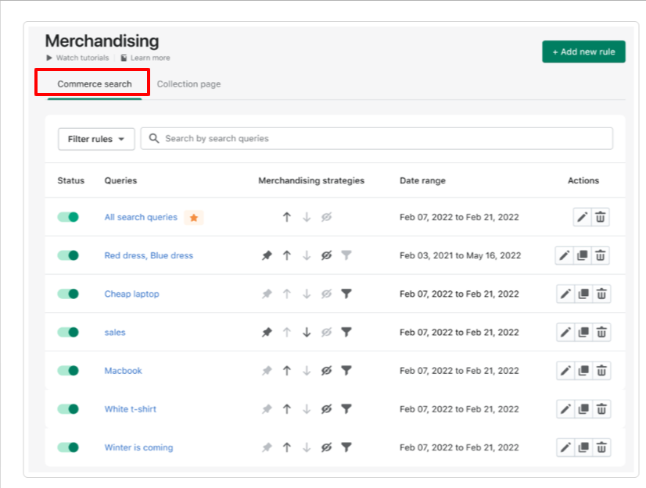

you'll see the rule listing page which is divided into two tabs Commerce search and collection page  
  
create a merchandising rule for Commerce search which applies to the instant Search widget and search  
  
click the add new rule button and select Commerce search  
  
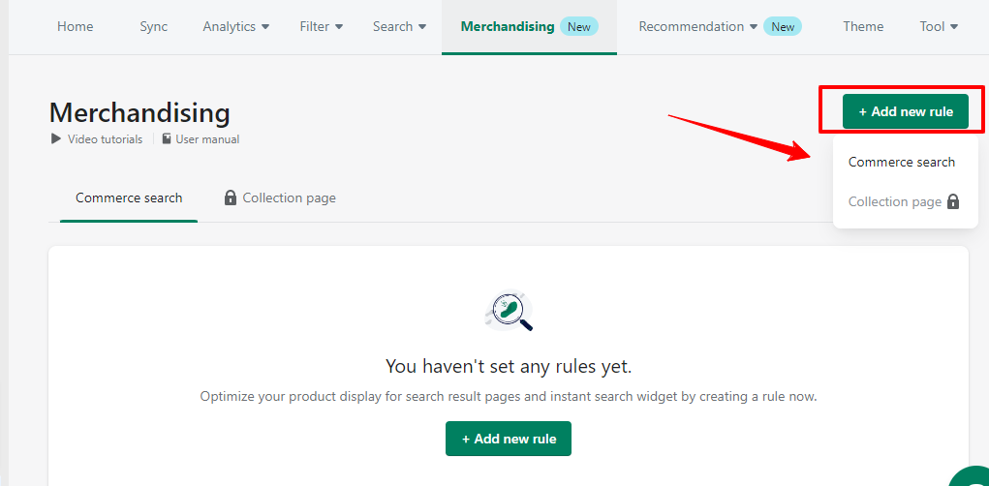  
  
Now set rule conditions including rule and choose if the rule is applied to specific or all Search terms it's possible to add multiple Search terms for one rule when your customers enter one of these Search terms in your store search bar the rule will be and you can apply up to five merchandising strategies including pin boost demote hide and filter for your rules but if you choose apply to all Search terms here you can apply only three merchandising strategies  
  
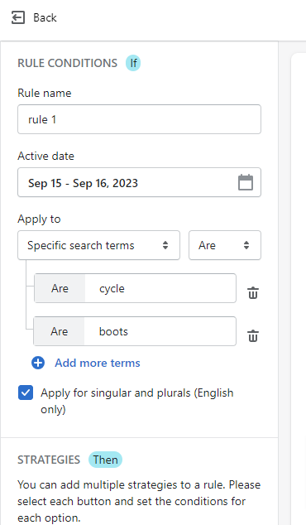

now set up the merchandising rules the settings for each strategy you selected are shown selected are shown on the right side of your screen the preview, with pin you can pin up to five products  
  
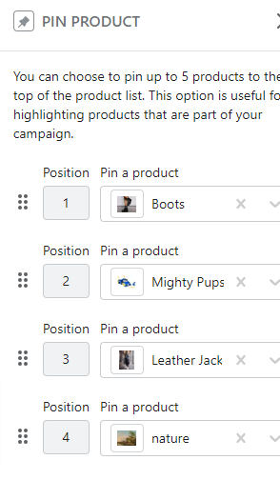  
boost allows you to promote products with certain attributes like vendor color price to the top of your organic result set under the Boost product section you can set up the conditions by deciding on which attribute of the product can activate the rule click add another attribute to add a new condition  
conditions you select will appear at the top of both the instant Search widget  
  
similar to boost demote allows to make specific products less visible based on their attributes; can add a maximum of three sets of conditions and three product attributes

1. for each condition the hide rule allows you to hide products that are seasonal or temporary   
     
   similarly you can set up the conditions for activating the rule by choosing the product attributes you want  
     
   finally the filter rule allows you to refine product searches and showcase specific products when is this rule applied  
   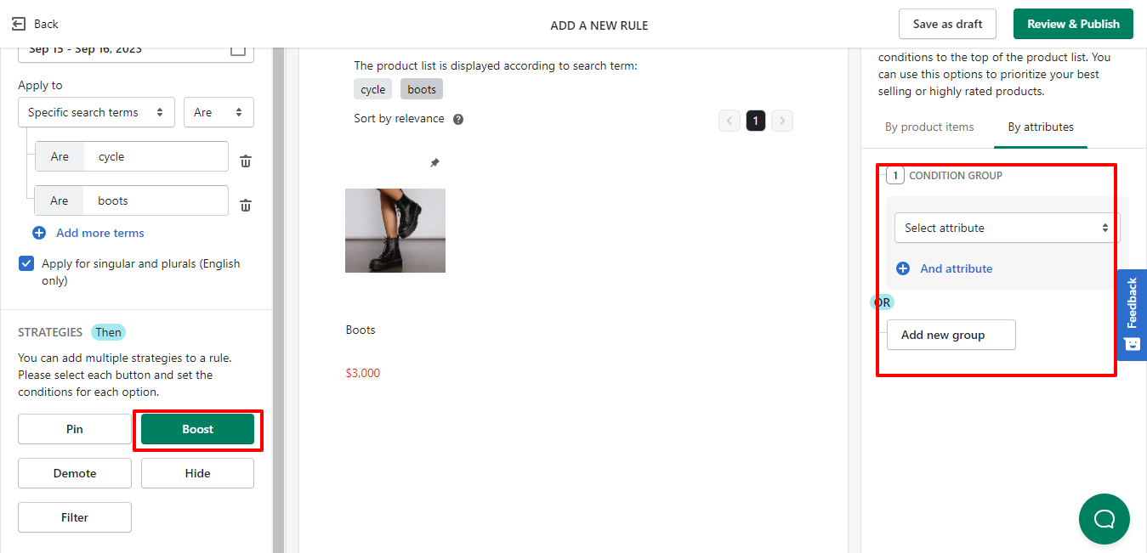  
   after creating the rules click review and publish to double check and apply the rule immediately and if you want to make further adjustments before publishing the rule choose save as draft  
     
   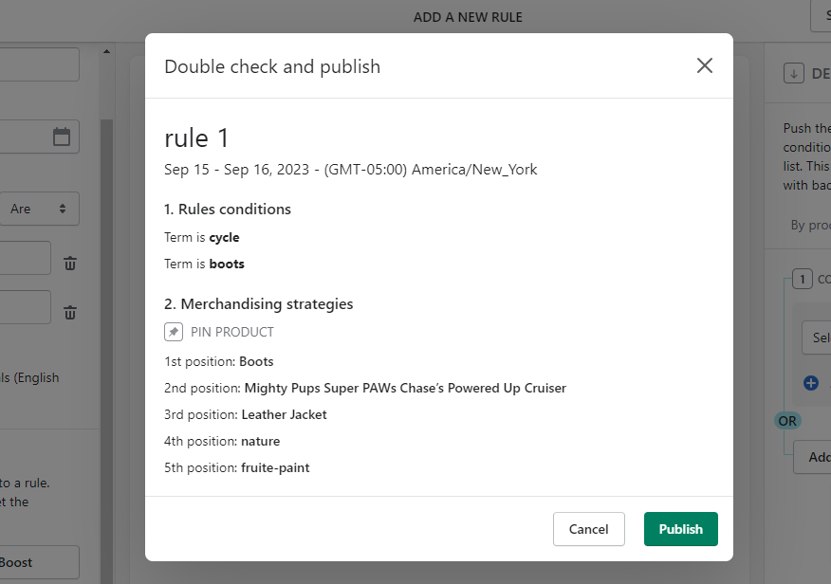

**Recommendation**Boost Recommendation lets you display various types of AI-based and manual recommendations for maximum cross-sell and upsell impact.  
  
Create a recommendation widget  
  
1. Open **Boost AI Search & Discovery**, from our app dashboard > **Recommendation**> **Recommendation widgets**

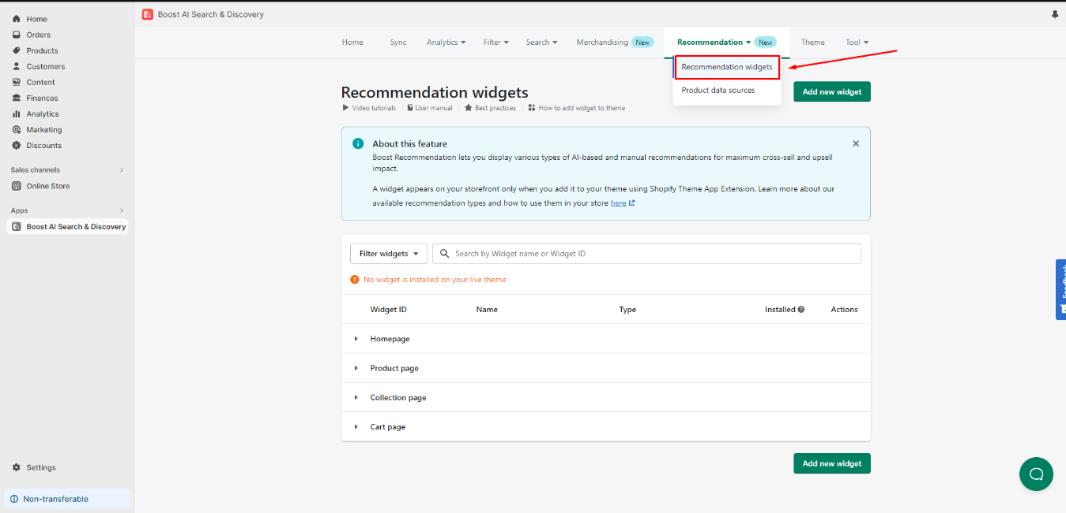  
  
2. Click **Add new widget**.  
  
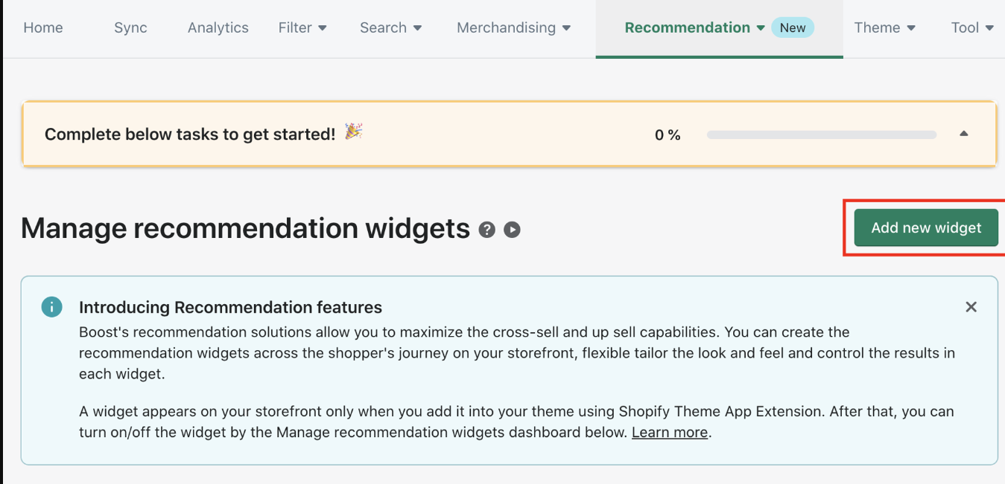

1. **Select Recommendation type**1. Select the page type you'd like to add your new Recommendation widget (Homepage, Product page, Collection page & Cart page).  
     
   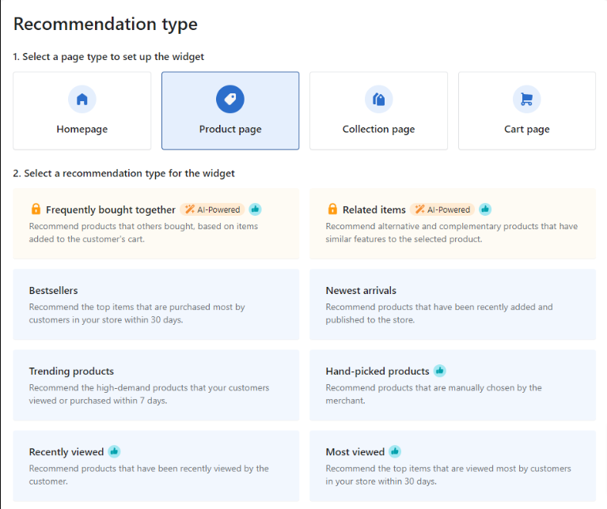  
     
     
   2. Keep in mind that each chosen page will correspondingly entail a distinct type of recommendation widget.  
   3. Click **Next.**

**Product data sources**

Create a hand-picked product widget

1. Go to **Recommendation** > **Recommendation widgets.**
2. Click **Add new widget.**
3. On the **Recommendation type** section, select **Product page** > select **Hand-picked products**> click **Next**.  
     
   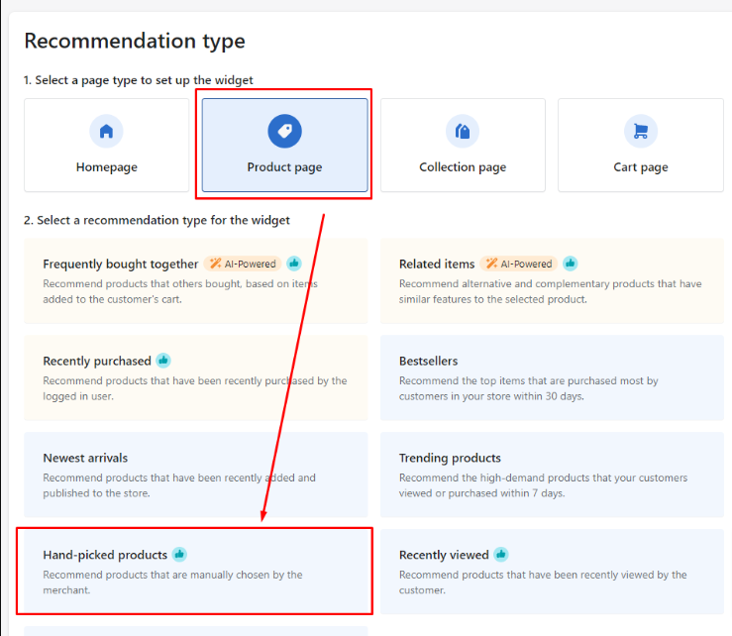

**Set rules for hand-picked products in Manual settings**1. From the app’s admin, go to **Recommendation** > **Product data sources.**

1. Click **Add new rule.**

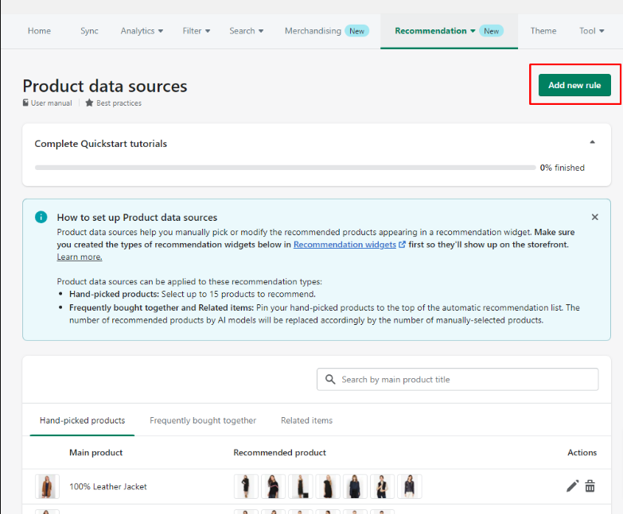3. In the **Conditions** section, click **Add product** and select the source product that you want to add recommendation list manually in popup **Main product**. Then click **Add** to save your action.  
  
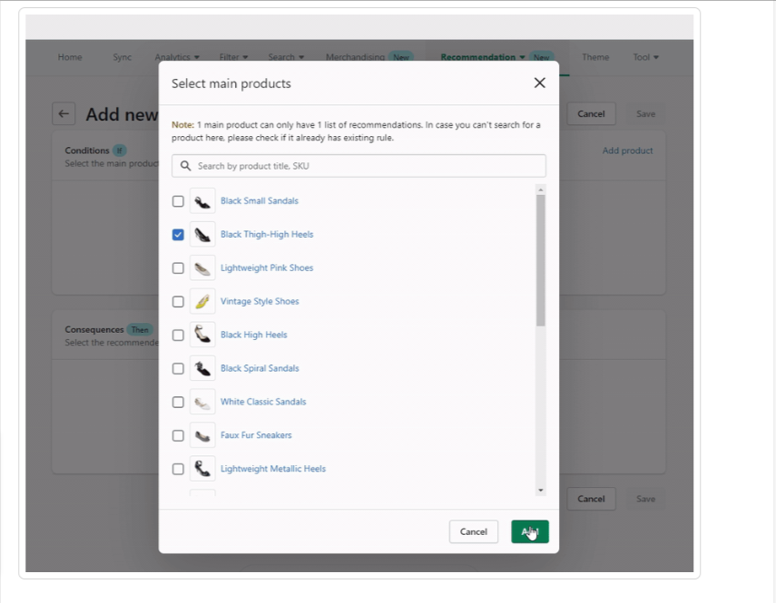  
  
4.In the **Consequences** section, click **Add product** and select all products you want to show as recommendations for the main product you have selected for the **Consequences**section in the popup **Recommended product**. Then click **Add** to save your action.

## **Theme Setup Auto theme setup flow**

### To implement our app on theme :

1. From the app’s admin, go to **Theme**> **Set up new theme.**

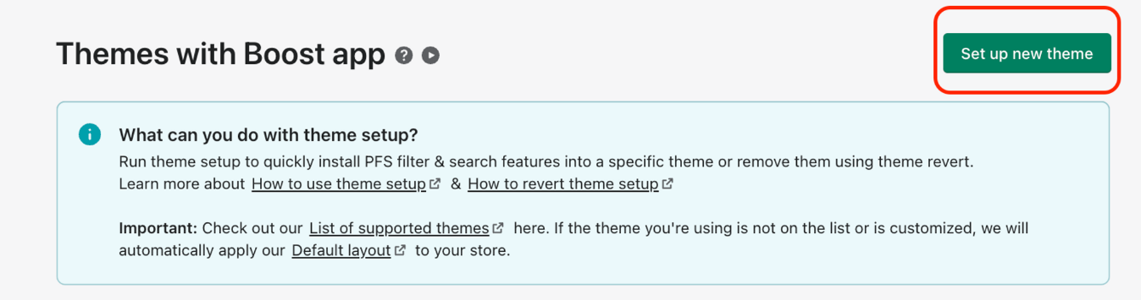

1. Select**[Target OS 2.0 Theme]**.  
     
   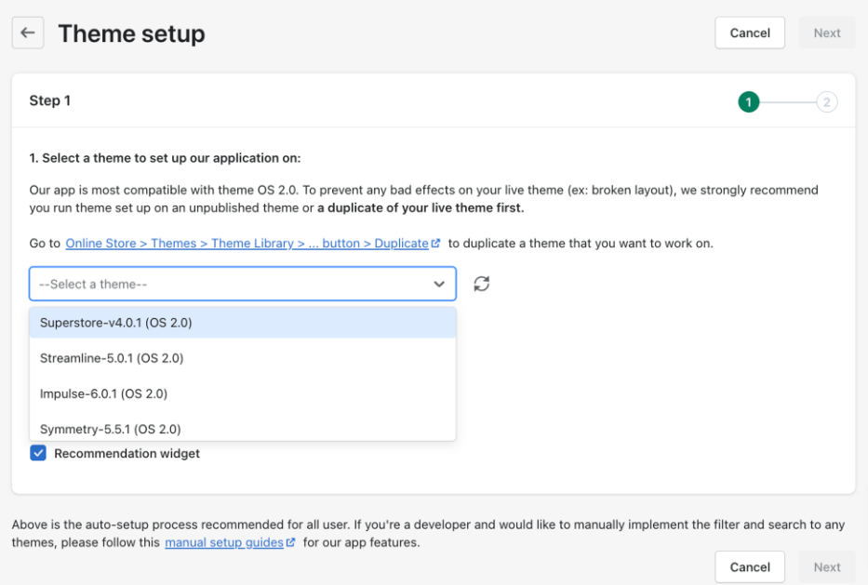

**3.** Select the features you want to install on  **[Target Theme]**.

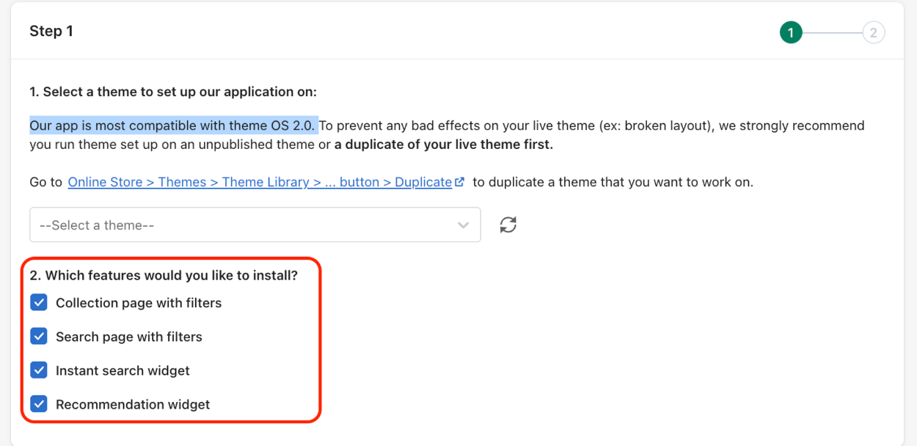

4. Select your preferred filter layout. You can have a look at demos of [vertical layout](https://boost-pfs-demo.myshopify.com/collections/vertical-layout) and [horizontal layout](https://boost-pfs-demo.myshopify.com/collections/horizontal-layout) before selecting your preferred one.

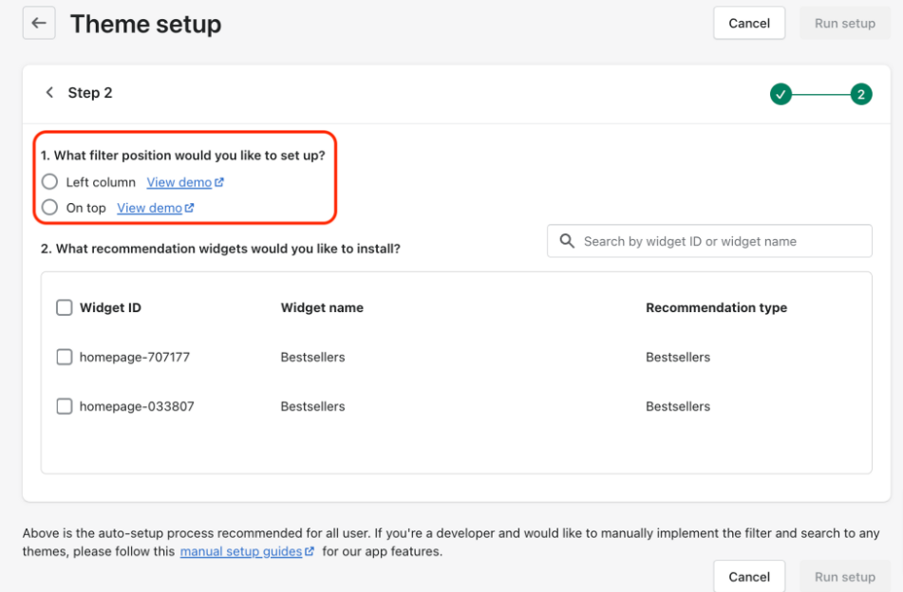  
5.If you select the recommendation feature to install, you are required to select recommendation widgets that were added to the recommendation feature settings.

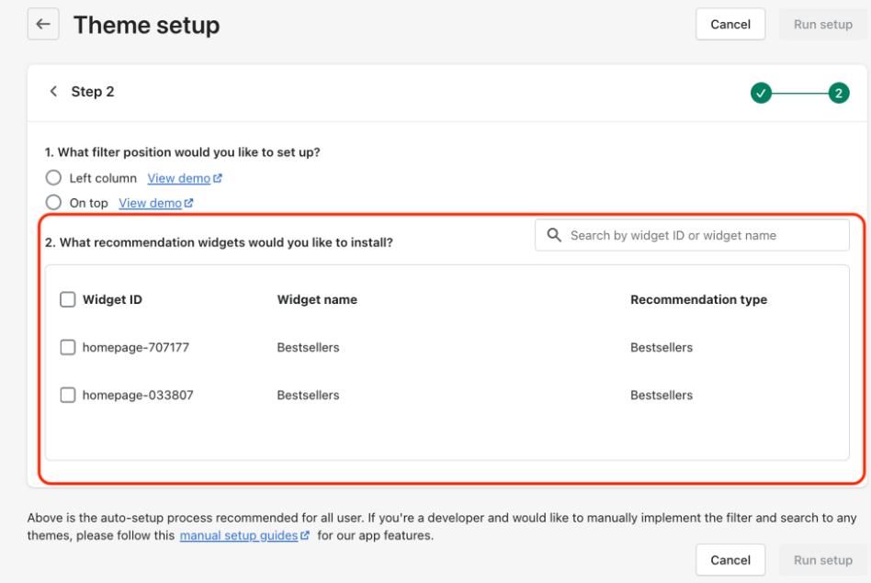

1. Click **Run Setup**. Wait until the process is complete.

## Manual theme setup flow

### **Recommendation feature**

**Step 1**: Open Shopify's Theme Editor.

1. In your Shopify admin, go to **Online Store**> **Themes**> **Customize**.

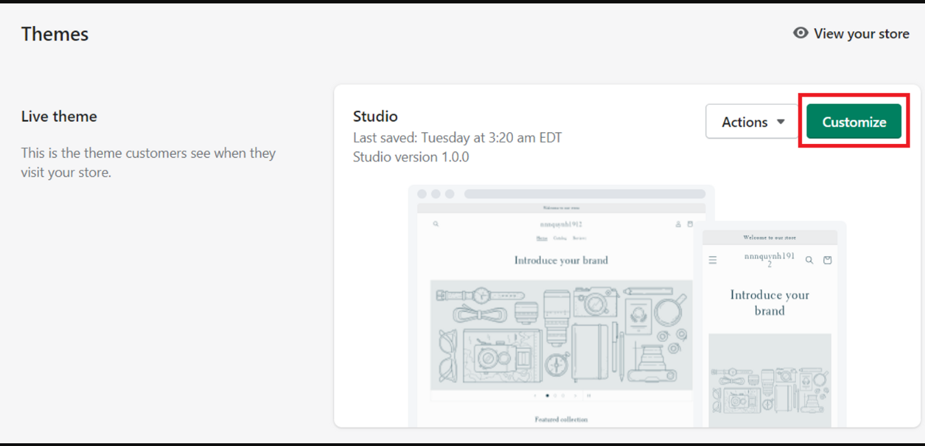

**Step 2**: Enable **Boost Core - app embed**.  
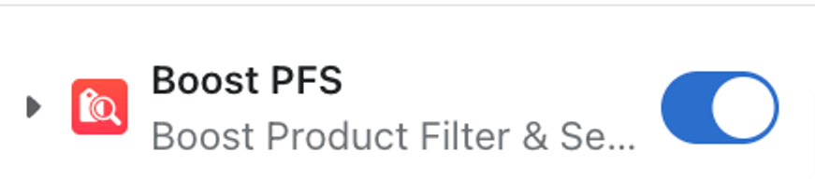  
**Step 3**: Add the recommendation widgets using app blocks.

1. Choose the template you want to add widgets.

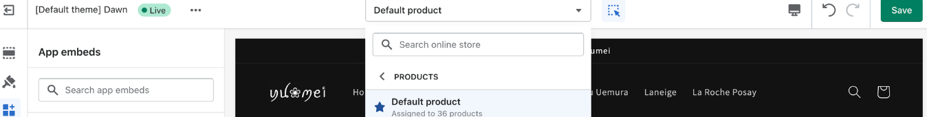

On the left-side menu, click **Add section**and choose the widget under **APPS.**

* Enter widget ID.  
  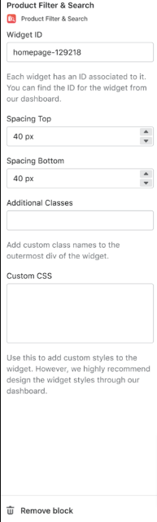
* Click **Save**.

### **Auto revert flow**

**To safely disable the app's features from a theme**:

1. From the app's admin, go to **Theme** > **Theme setup**.
2. Find **[Target Theme]** that the app injected its code into, whether it is the live theme or the themes that you plan to set live in the future.
3. Go to **Actions** > select:

* **V2**
  + **Remove search feature only** if you want to disable the search feature.
  + **Remove all filters & search features** if you want to disable all the app’s features.
  + Select **Remove.**
* **V3**
  + Select **Remove our app features.**

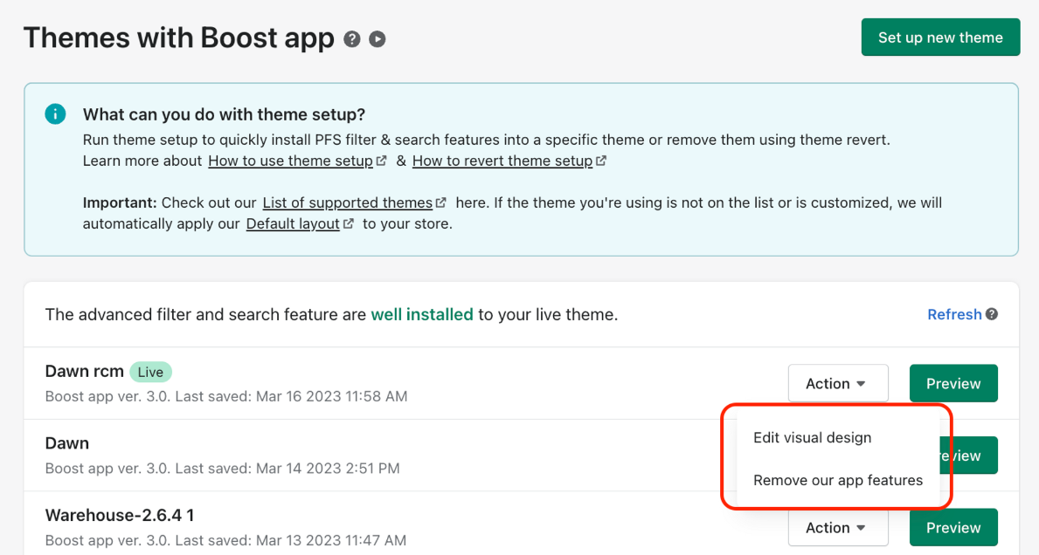

* Select the features you want to remove from your theme > Select **Next.**

**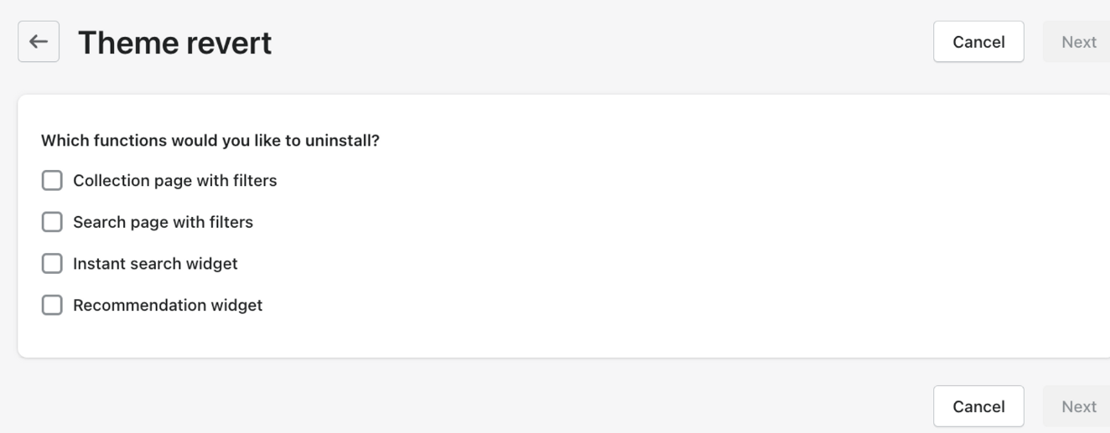  
  
Manual revert flow  
  
To manually revert themes with theme app extension:**

1. From your Shopify admin, go to **Online Store** > **Themes.**
2. Find the theme you want to remove the app's code, and then click **Customize**.
3. In the **editor left sidebar**, select **App embeds** > Disable **Boost Core** - app embed in the list of **App embeds**.
4. Remove all our app blocks in all templates > Restore any default app blocks you may have before installing our app.
5. go back to your **Shopify Admin Dashboard**> **Sales channels**> **Online Store**> **Themes**.
6. From the same theme, click the "**⋯**" button > **Edit code**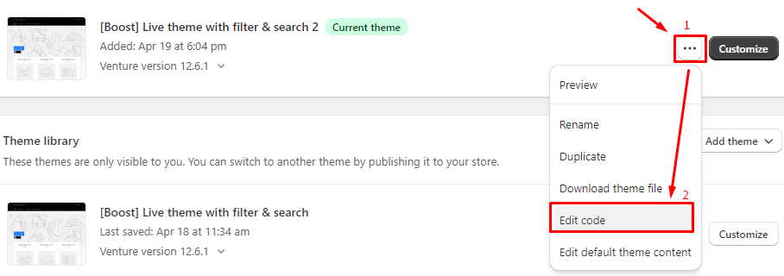
7. Locate the "**Snippets**" folder in your theme files > find this file named "**boost-sd-fallback.liquid**" and delete it.
8. Click **Delete file**to confirm your action.
9. Next, we locate your theme's **Layout**folder, go to "**theme.liquid**" file.
10. Search for this line of code below and delete it.

### {% render 'boost-sd-fallback' %} 11. Click **Save.**

**\*\*\*\*\*\*\*\*\*\*\*\*\*\*\*\*\*\*\*\*\*\*\*\*\*\*\*\***